SQL PROGRAM

create database crud;
show databases;
use crud;
CREATE TABLE `user` (
`sl_no` INT(5) NULL DEFAULT NULL,
`name` VARCHAR(100) NULL DEFAULT NULL,
`email` VARCHAR(100) NULL DEFAULT NULL
)
COLLATE='latin1_swedish_ci'
ENGINE=InnoDB
;

PROJECT STRUCTURE IN ECLIPSE IDE

MYSQL_CRUD
src
CRUD
CRUD_Test.java
DB_Connection.java
JRE System Library
Referenced Libraries

Connection Class to get connection with MySql
DB_Connection.java

package CRUD;
import java.sql.Connection;
import java.sql.DriverManager;
public class DB_Connection {
public static void main(String[] args) {
DB_Connection obj_DB_Connection=new DB_Connection();
System.out.println(obj_DB_Connection.get_connection());
}
public Connection get_connection() {
Connection connection = null;
try {

Class.forName("com.mysql.cj.jdbc.Driver");

connection = DriverManager.getConnection(
"jdbc:mysql://localhost:3306/crud", "root", "Sid#8749");
System.out.println("Connection successful!");
} catch (Exception e) {
e.printStackTrace();
}
return connection;
}
}

OUTPUT:
Connection successful!
com.mysql.cj.jdbc.ConnectionImpl@3d3fcdb0

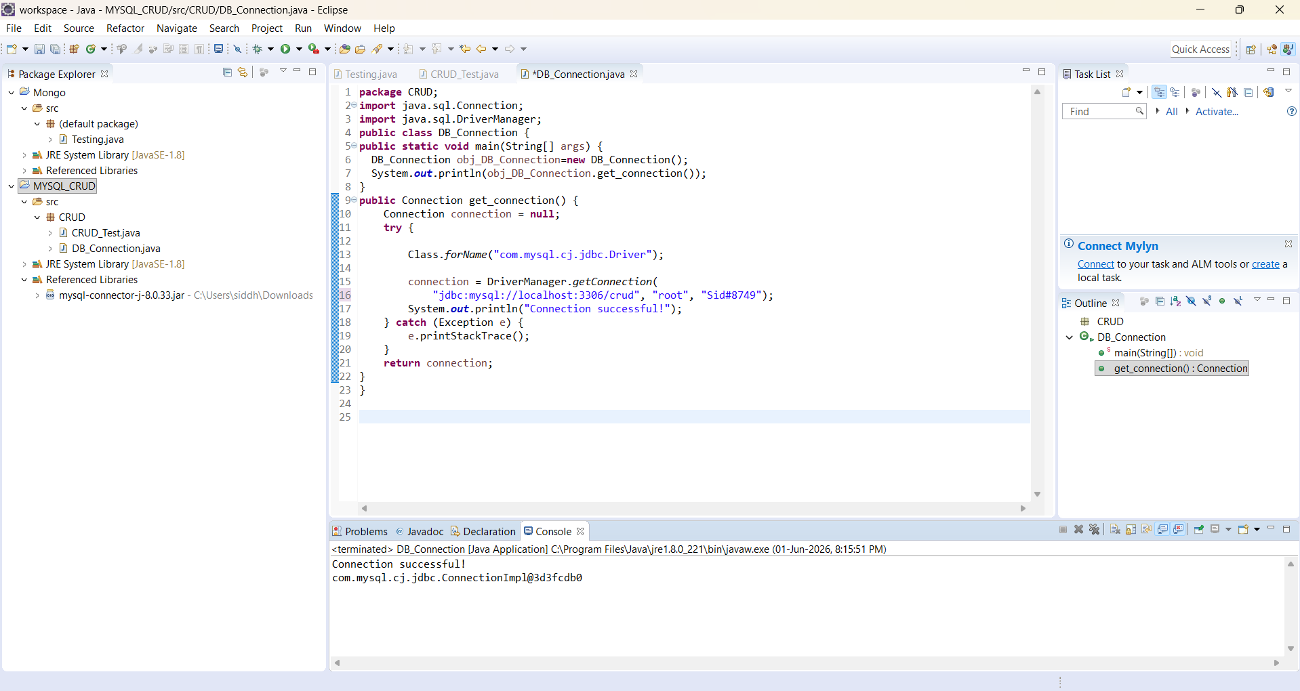

CRUD_Test.java

package CRUD;
import java.sql.Connection;
import java.sql.PreparedStatement;
import java.sql.ResultSet;
public class CRUD_Test {

public static void main(String[] args) {
CRUD_Test objTest=new CRUD_Test();
//insert data
objTest.create_data("1", "jinu", "jinu@gmail.com");
objTest.create_data("2", "jawad", "jawad@gmail.com");
//read data
objTest.read_data("2");
//update data
objTest.update_data("2", "22", "jawad2", "jawad2@gmail");
//delete data
objTest.delete_data("1");
}

public void create_data(String sl_no,String name,String email){
DB_Connection obj_DB_Connection=new DB_Connection();
Connection connection=obj_DB_Connection.get_connection();
PreparedStatement ps=null;
try {
String query="insert into user(sl_no,name,email) values (?,?,?)";
ps=connection.prepareStatement(query);
ps.setString(1, sl_no);
ps.setString(2, name);
ps.setString(3, email);
System.out.println(ps);
ps.executeUpdate();
} catch (Exception e) {
System.out.println(e);
}
}

public void read_data(String sl_no){
DB_Connection obj_DB_Connection=new DB_Connection();
Connection connection=obj_DB_Connection.get_connection();
PreparedStatement ps=null;
ResultSet rs=null;
try {
String query="select * from user";
ps=connection.prepareStatement(query);
//ps.setString(1, sl_no);
System.out.println(ps);
rs=ps.executeQuery();
while(rs.next()){
System.out.println("Sl no -"+rs.getString("sl_no"));
System.out.println("name -"+rs.getString("name"));
System.out.println("email -"+rs.getString("email"));
System.out.println("---------------");
}
} catch (Exception e) {
System.out.println(e);
}
}

public void update_data(String sl_no,String new_sl_no,String name,String email){
DB_Connection obj_DB_Connection=new DB_Connection();
Connection connection=obj_DB_Connection.get_connection();
PreparedStatement ps=null;
try {
String query="update user set sl_no=?,name=?,email=? where sl_no=?";
ps=connection.prepareStatement(query);
ps.setString(1, new_sl_no);
ps.setString(2, name);
ps.setString(3, email);
ps.setString(4, sl_no);
System.out.println(ps);
ps.executeUpdate();
} catch (Exception e) {
System.out.println(e);
}
}

public void delete_data(String sl_no){
DB_Connection obj_DB_Connection=new DB_Connection();
Connection connection=obj_DB_Connection.get_connection();
PreparedStatement ps=null;
try {
String query="delete from user where sl_no=?";
ps=connection.prepareStatement(query);
ps.setString(1, sl_no);
System.out.println(ps);
ps.executeUpdate();
} catch (Exception e) {
System.out.println(e);
}

}
}

OUTPUT:
Connection successful!
com.mysql.cj.jdbc.ClientPreparedStatement: insert into user(sl_no,name,email) values ('1','jinu','jinu@gmail.com')
Connection successful!
com.mysql.cj.jdbc.ClientPreparedStatement: insert into user(sl_no,name,email) values ('2','jawad','jawad@gmail.com')
Connection successful!
com.mysql.cj.jdbc.ClientPreparedStatement: select * from user
Sl no -1
name -jinu
email -jinu@gmail.com
---------------
Sl no -2
name -jawad
email -jawad@gmail.com
---------------
Connection successful!
com.mysql.cj.jdbc.ClientPreparedStatement: update user set sl_no='22',name='jawad2',email='jawad2@gmail' where sl_no='2'
Connection successful!
com.mysql.cj.jdbc.ClientPreparedStatement: delete from user where sl_no='1'

